

ITA0330-Mobile Computing

Name: T. Dharani Devi Reg no:192425036

Slot: D Course Name: Mobile Computing

Experiment 3: Network Switching Subsystem Flowchart
Aim: To develop a flowchart depicting the operation of a Network Switching Subsystem (NSS) in a mobile cellular system.
Procedure:
- Open Figma and create a new design file.
- Create a frame for the NSS flowchart.
- Add a start symbol and a mobile user requesting a call.
- Add MSC, HLR, VLR, AuC, and EIR components.
- Connect the components using arrows to represent the call-processing sequence.
- Add decision points for authentication and call routing.
- Use different colors for each stage and arrange the flowchart clearly.

Output:
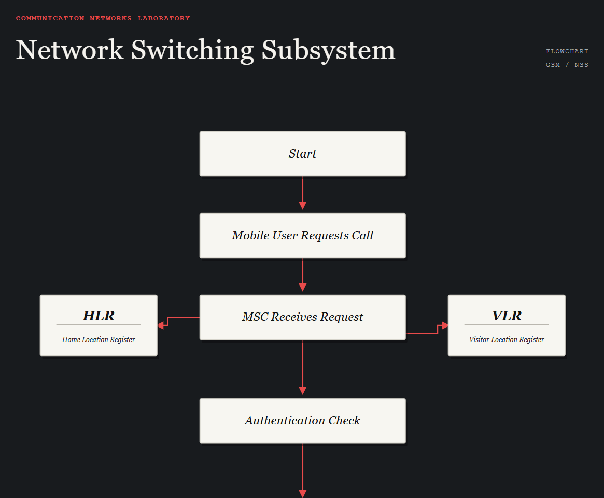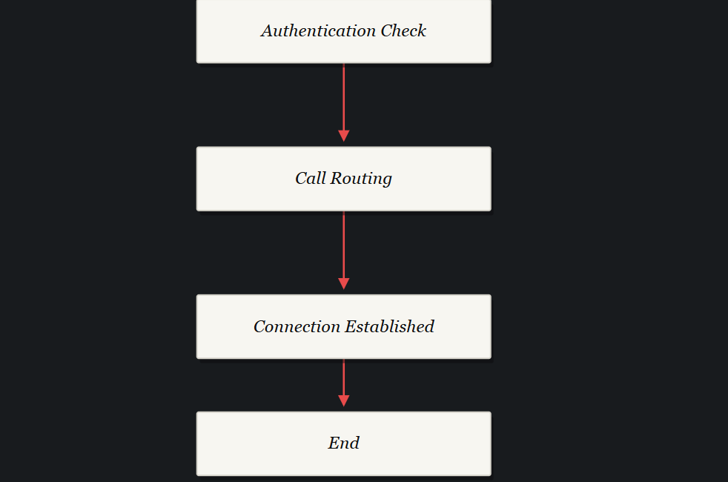

https://www.figma.com/make/2zYhFZqYaUdzvNrcxHJhRr/EXPERIMENT-3?p=f&t=b9jNHz1lY47UxIVc-0

Result: Thus, a flowchart representing the operation of the Network Switching Subsystem was developed successfully using Figma.

